

**NEF6001**

**Research Project Part A**

**FINAL REPORT**

**Impact of Internet of System/Technology in Agricultural Development in India**

Trimester: 2 / 2019

**Student Name: Surbhi Dhawan**

**Student ID: 4608520**

**Supervisor Name: EGWUTUOHA, Ifeanyi**

**Total Mark= 50%**

Table of Contents

**1.0** **Abstract** 2

**2.0 Introduction** 3

2.1 Agriculture in India 4

2.2 Internet of Things in Agriculture 5

**3.0 Research Project Background and Objectives** 9

**4.0 Literature Review** 10

**5.0 Research Problems** 14

**6.0 Research Methodology** 15

**7.0 Research Significance** 18

**8.0 Conclusion** 19

**9.0 Research Planning:** 19

**10.0 References** 21

# **Abstract**

Internet of things (IOT) is the big invention that is used for interconnecting various devices in a system to sense the interactions among different devices in a system. IOT is extending in every field such as medicine, health, homes, agriculture, and many more. This paper includes the application of Internet of Things in agriculture as this field needs to be more developed in terms of technology. Agriculture is one of the oldest occupations that plays a crucial role in Indian economy. As we know India is a geographical area and is famous country for agriculture. It is second largest country in agriculture production. The agriculture of India is based on different seasons. So, this paper is based on Indian agriculture. With the increase in population agricultural practices needs to be modified to make the crop yield more reliable. Many projects in India has been started (Baruah, A. and Mohan, G.M., 2018) like world bank Invested in Pan India Project like National Agriculture Technology Project in Coordination with Indian government. According to Food and Agricultural Organisation, food productions needs to be increased by 70% of the current production and for this IoT can be best practice to make the agriculture smart. By using the IOT in agriculture we can level the fields, know the nature of the soil, provide essential nutrients to soil, can use write fertilizer, manage crop yield, manage livestock, sense weather variations, perform automated irrigation which can reduce man power. As we know agriculture can be improved with the more reliable technologies used. A research study from IBM found that 90% of lost crop could be prevented by using the latest agricultural techniques. Big data, Cloud Computing, IOT, Sensors can combine to make good use of the technology. In the first part of the paper conditions of farmers is specifies and difficulties faced by them is using the latest technologies. Some natural difficulties faced by farmers like scarcity of water (Satyanarayana, G.V. and Mazaruddin, S.D. , 2013), over use of natural resources can also be resolved by using IOT.After reading many journals, articles, and blogs literature review is mentioned to go deep in the study. The proposed methodology is qualitative and for stages of the research have been discussed. We can use Iot in agriculture but there is no point of using if actual people are not able to use it that are farmers. This research paper is dedicated to those farmers who are not able to use these technologies due to high illiteracy rate. In India more than 60% of farmers belong to below poverty line and are not able to use the technology. The second reason is lack of knowledge and awareness among farmers about soil conditions. Lack of infrastructure and expensive equipment’s slows down the usage of Iot in agriculture. the proposed solutions can be effective if implemented correctly. This will extend my research to part b.

**Keywords:**

1. **Agriculture**
2. **Internet of Things**
3. **Agriculture in India**

# **2.0 Introduction**

The advancement of agriculture and its role plays a crucial role in a country’s economy and development. It produces jobs to a lot of people and its bread and butter to many countries across the world. As the population is increasing day by day, there is a need to look on the agriculture sector. In some country’s agriculture is the foundation of the economy and one of the countries among many is India. It is surveyed that it employs 54.6% of nations workforce (Agricultural Statistics at a Glance, Ministry of Agriculture and Farmer’s Welfare, GoI, 2016). The above image depicts the contribution of Indian population in different sectors of India. About more than 50% of Indian population is involved in agriculture sector as compared to other sectors.

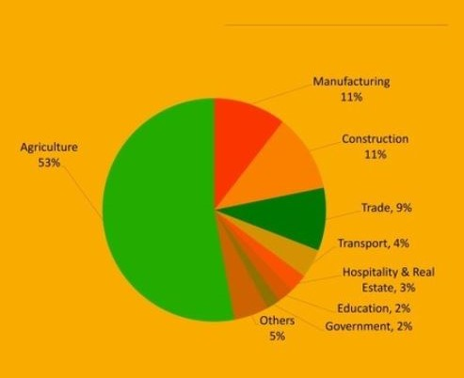

**Figure 2.1: ROLE OF DIFFERENT SECTOR IN INDIAN ECONOMY** (grdp, 2016)

**Keywords:**

1. **Agriculture**
2. **Internet of Things**
3. **Agriculture in India**

## 2.1 Agriculture in India

Agriculture is a practise of science that includes farming, cultivation of soil, rearing and breeding of animals to obtain food and various other amenities from them. Farming in India is done according to suitable places that have the environment of agriculture. Farming systems in India are based on subsistence cultivation, modern agriculture and natural cultivation. India is a geographical area, so every area is considered to be different for different agricultures like some use horticulture, agroforestry, ley farming etc.

India is second largest country in agriculture production. The agriculture of India is based on different seasons. The figure shows the areas where the Internet of things are used in agriculture like knowing weather conditions, moisture of soil, farming, quality of crop.

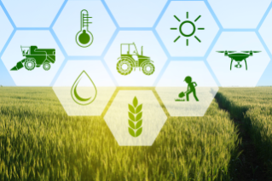

**Figure2.1.1: applications of IOT in agriculture**

## 2.2 Internet of Things in Agriculture

Internet of things or IOT are the system that has many devices that are interrelations and provides zero involvement of humans to interact with each other. It is the biggest invention of technology that is spreading widely across the world. nowadays IOT are used in smart homes, elder care, medical and health, industrialisation and agriculture.

In agriculture IOT has evolved a lot. There are many applications created that can help in

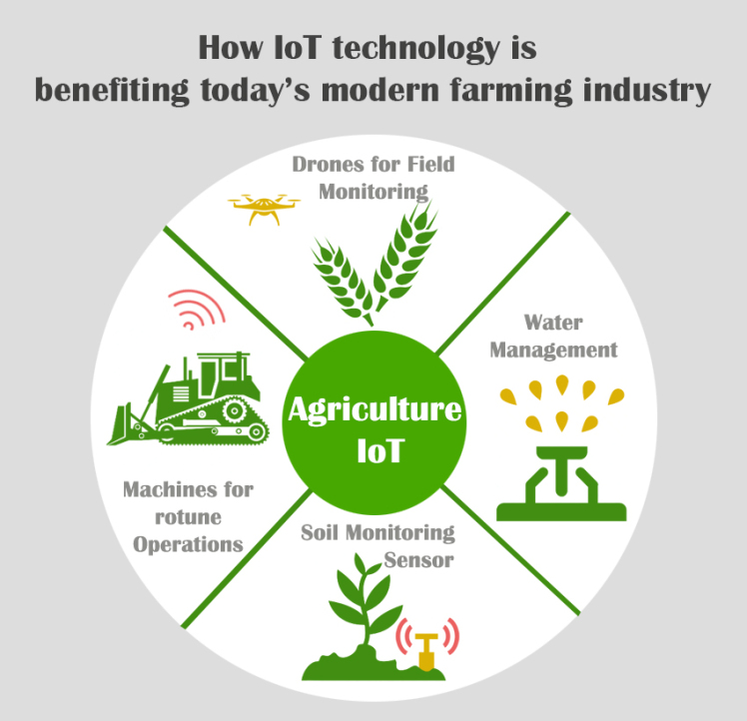

**Figure 2.2.1: Benefits of IOT in farming** (Techno FAQ, 2018)

farming like collecting data on humidity, temperature, soil content, pest infestation, rainfall etc. this all information can be utilized in computerising the farming strategies to take important decisions on when and how is to be done as it can improve quantity and quality of the production and reduces risk and wastage and hard work and minimised manpower.

As agriculture is very important aspect of every Country, wider number of practices come every year and evolve, and some makes huge profit. In India, there are huge producers who follow Agriculture practices on small scale as well as large scale. Indian agriculture is facing many lacks opportunities and needs. For future purposed this area needs more attention to glorify. Most small-scale farmers are not aware of technology that can be used in agriculture and that can help them to grow.

Many projects in India has been started (Baruah, A. and Mohan, G.M., 2018) like world bank Invested in Pan India Project like National Agriculture Technology Project in Coordination with Indian government.

Some smart agricultural products that are and would be used in India are:

In Bengaluru, Open Source Labs are working to create a device based on IOT that is friendly to farming practices. It checks crops health, smart irrigation system, soil condition and smart livestock management. This system uses hardware’s like raspberry Pi and Arduino along with ESP.

AGNext a Punjab based company started using smart agriculture in Precision farming. It combines both Machine learning and Artificial intelligence. This created more reliable solutions to the farmers for smart farming. In India more than 40 projects are running based on IOT smart agriculture which is reported by National Association Of Software and Services Companies (NASSCOM).

Monitoring of climatic conditions: weather stations combined with smart farming sensors, located across the field collects data and sends to cloud.

Some examples of such agriculture IoT devices are [allMETEO](https://www.allmeteo.com/), [Smart Elements](https://smartelements.io/), and [Pycno](https://www.pycno.co/). For instance, [Farmapp](https://farmappweb.com/) and [Growlink](http://growlink.com/) are also IoT agriculture products offering such capabilities among others.

In India, internet of things is a new age technology which is spreading day by day. It is estimated that by using IOT in agriculture it will increase the annual rate of growth by 13%.

The figure shows various areas of agriculture where farming can be used like precision farming, farm management, smart dairy, cultivation and analysis etc. and how it is used like sensors are used.

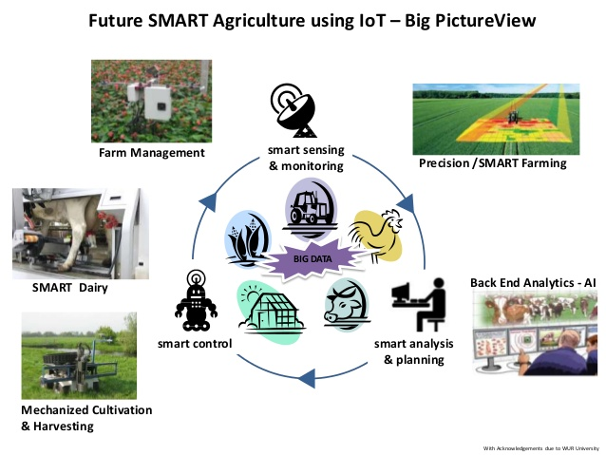

**Figure 2.2.2: Usage of IOT in various areas of agriculture** (Lawrence, 2019)

As we know agriculture can be improved with the more reliable technologies used. A research study from IBM found that 90% of lost crop could be prevented by using the latest agricultural techniques. The latest technology should have following features like automatic reminders, alerts or warnings when the soil needs nutrients or lacks the basic elements in soil. By using the modern techniques, we can point out where the problems arise like from storage to transporting of the crops by simple mobile device. And if any complication arises, we can fix it by using out mobile. Not only crops, we can also manage the livestock, and the conditions of ground. Drones can be used by using thermal cameras which can sense the temperature variation at different places of land. And, the livestock can be managed. By using advanced technology, we can cure the crop disease before It spreads. By using sensors farmers gets a transparent view of crop management, the crop yield and performances. The benefits of using smart agriculture are:

* **Efficiency**: as agriculture is a very unique practice. Farmers anyhow has to grow crops in any condition of the soil. IOT has helped the farmers to monitor the crop cycle from start to end. They get fast inputs and reliable outputs. They have influenced technology by automated irrigation, easy harvesting etc.
* **Expansion**: out of the total population of India, more than 70% live in urban areas. IOT based food should be able to feed these people with healthy food.
* **Prevent Overuse of Resources:** By using IOT in agriculture most of things has taken easy place. Now by smart agriculture, we can come to know exact nutrient supply to the soil. We can even know which fertilizer is best for the soil. By using automated irrigation, large fields can be irrigated only when required, which helps is saving of water table.
* **Agility:** The use of IOT has eventually increased the agility of the whole process. As it is real time monitoring, farmers can instantly act on the conditions like, changing weather, soil humidity, crop disease etc which can save a lot of time and effort.
* **Improves the quality of the crops.**

The above image shows the typical scenario of using fully smart agriculture in a land.

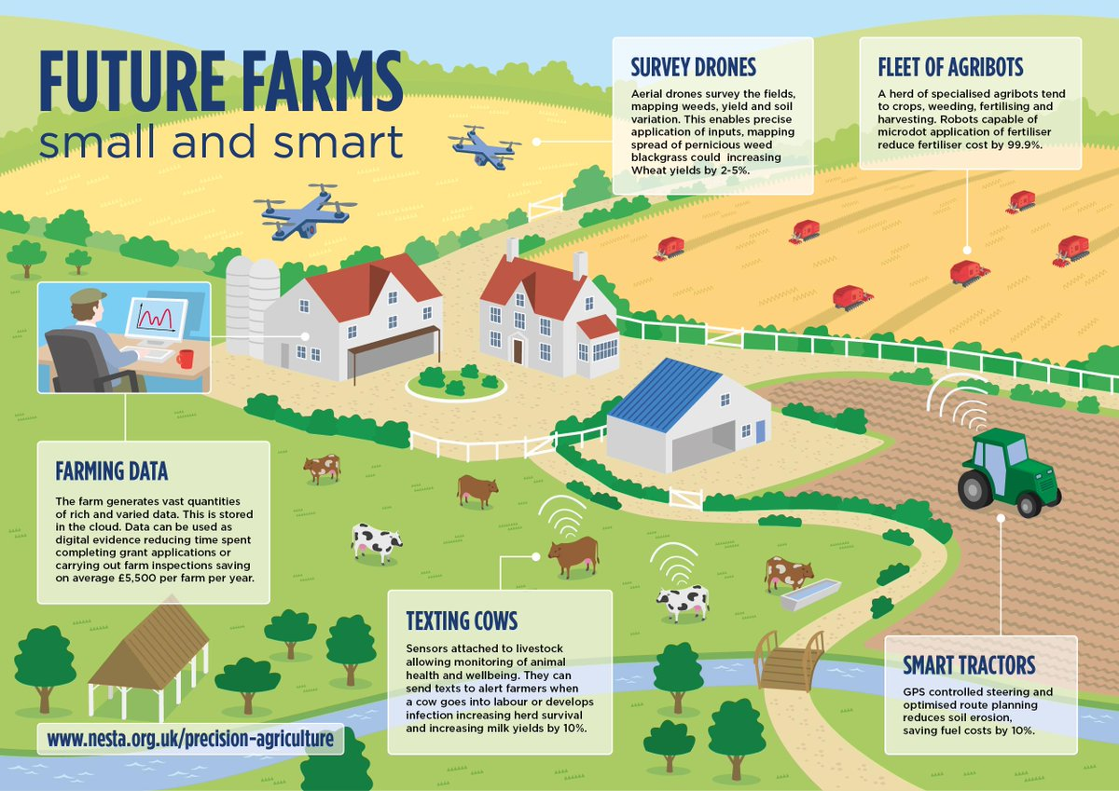**Figure2.2.3: smart agriculture farm scenario** (twimg,2019)

So, this research will be about impact of internet of things on agriculture especially in India and the challenges faced by Indian population to consider IOT in agriculture. As we know, in India small scale farmers still use traditional practices for agriculture despite of so many technologies in market and fails in obtaining quality crops. As an Indian citizen, I have seen many problems faced by farmers in agriculture which lead to severe problems.

Despite of many IOT technologies, only few large-scale farmers stated implementing them. As farmers needs agricultural data to make firm decisions and to fulfil instructive needs. IOT needs to spread widely. This research paper is very important for the industry practise as it will list the present technologies and their impacts on agricultural development.

# **3.0 Research Project Background and Objectives**

Various motivations led me to do research on this topic. As we all know, IOT is emerging day by day and to replace traditional practices of farming IOT is playing a very important role.

My research specifically is based on Indian agriculture because with advancement of technology India is also moving with it. But the agricultural practices are still traditional. Due to illiteracy many farmers don’t know or are not aware of many technologies that can make their work easy and prominent. Moreover, this paper will focus on the impact of IOT in agriculture of India like whether it is helping the economy or not.

Throughout the years, there are many study articles that are composed by many researchers’ specialists in terms of IOT. As it is always agreed that technology is not static. And in the field of IOT there have been many technologies that got invented in market and used in the world in agriculture and in India.

After reviewing many papers, there are several papers that tell us about technologies that are present in the market and used widely. According to UN food agriculture and organisation, to feed the population of the world, agriculture needs to produce more than 70% of food in 2050. For this farmers and agricultural companies need to reach to IOT to meet the demands. There are many barriers in producing food, like climate change due to which productivity decreases. But smart agriculture can cross these barriers and can increase the productivity. Several papers provide reviews on currently present IOT systems and how they help in agriculture.

The objective is also to give reviews on how IOT is affecting the agriculture: positive or negative and how to help small farmers to use this IOT.

After going through several papers, most of the researchers choose this sector for research people who are unaware. The list of problems that I came around after reading papers are very serious. The first problem is earning of a farmer is very low. It is 32 bucks of Indian currency per day which is nothing for a person. Most of the Indian farmers belong to below poverty line and use traditional practices as they cannot afford the present technologies. Most of the papers focuses on the lack of adoption of the modern farming. The second reason is that people are illiterate. They are not aware of what is going on in the market. In India, the smart farming is only used by the people that are rich enough or the government sectors that have huge funds to invest in the large projects.

As India is a geographical area, the soil texture keeps on changing. The farmers are not aware of the soil knowledge. Lack of infrastructure is also a problem for the farmers. Affordability of these equipment’s is a big question.

These all problems are listed in the research problems and possible solutions are mentioned.

This article evaluates contributions done by many researchers in field of IOT in agriculture and highlights the prominent application of IOT in agriculture that are present and the impact of IOT on Indian agricultural market and challenges faced by using smart agriculture and future directions to support the article.

Research will be done by examining the journals and articles and existing literature in the context.

# **4.0 Literature Review**

The papers that have been discussed above are deeply studied and then reviewed. I read many papers and reviewed thirteen of them above.

**Vasisht, D., Kapetanovic, Z., Won, J., Jin, X., Chandra, R., Sinha, S., Kapoor, A., Sudarshan, M. and Stratman, S. (2017)** This paper introduces the data driven techniques that are used in IOT to increase the productivity of crops, to manage livestock and to properly monitor the land. This paper proposed a platform named Farm Beats for data collection from various parts of fields using sensors. This research was carried out in US. Focusing on the increasing demands of food . Data driven techniques can help in increase in yield of food. The goals that have been targeted in Farm Beats are: convenience , capacity, cloud connectivity, and data freshness. Architecture involves Sensors and drones, Iot base station, IoT gateway, Services and the cloud. The algorithm is called duty Cycle which has key goals like: Variable access, energy neutrality, minimising data approach. The implementation is done based on the given details and reliable outputs were measured. This technique is reliable technique and is US based but it can be implemented in India as well. This research can be used powerfully in terms of exiting applications for better results.

**Satyanarayana, G.V. and Mazaruddin, S.D. (2013)** focuses on the sensor development which can be used in agriculture. It focuses on problem of farmers when uneven distribution of rain causes damage of crops and result in loss. In this paper the authors proposed and implements a wireless sensor network connected to a node which is known as zigbee. The zigbee is connected to Central Monitoring station (CMS) through GPRS (General Packet Radio Service) or GSM (Global System for Mobile) technologies. This proposed system can help farmers in analysing the conditions of soil. In this paper the designing and implementation is also done in order to supply proofs to the situations. Overall this paper is a good paper to know about what can be the latest technologies that can be easily used to develop agriculture in India, but it lacks focus on the main point that the affordability of these equipment’s.

**Verma, N.K. and Usman, A., (2016)** discusses about the current conditions of farmers and how IOT can help them to change the total scenario of agriculture. This paper discusses about the problems farmers face while performing agricultural practices like uncertain weather conditions which can lead to destruction of soil etc. the second problem, they focused on lack of soil knowledge. The researchers proposed model for IOT smart device that could make the work of farmers easier. The proposed IOT device will help farmers to know the nature of the soil and best suited crop for that soil and the water required to grow crops and requirement of fertilizers in the crop management. Weather forecasting and theft protection are two more features that have added in this paper in local language so that farmers could easily understand the fundamentals of the IOT smart device. The proposed software has eco-friendly energy management so that it does not negatively affect the environment. This paper has clearly viewed the situation of the farmers and gave a clear proposed model for the agricultural smart device, but it is not cost effective which can be easily affordable by the small-scale farmers.

**Mwangi, M. and Kariuki, S., (2015)** discusses the condition of small holder farmers and elaborates factors that are leading to need off new technology in agriculture. Agriculture produces 2.5 billion of income (FAO,2003) to people in world. This paper has focus on small scale farmers that still use traditional practices to production. Near about 70% if maize production is by small holder farmers and they use traditional practices to grow. Due to the conditions going on in the farming industry the paper reviewed various old research papers that are influencing the adoption of new technology in agriculture. Economic, technological, household, institutional factors have been elaborated completely in order to support the context. It is a review paper which focuses on adoption and urges government and policy makers to make certain policies that may help them to adopt it easily by understanding the needs of farmers as well. This paper main focuses on small scale farmers which is really the main aim of my research and I will use this paper for further research.

**Mohanraj, I., Ashokumar, K. and Naren, J. (2016)** is a recent approach towards improving agriculture in India. Authors throws light on the current scenario of agriculture in India. The current agriculture production in India is diminishing day by day due to traditional practices. The production is either getting replenished or low due to old farming techniques. This paper proposes a e-agriculture farming app framework consisting of knowledge and modules. This app will be useful for farmers to make profitable decisions in agriculture as it will include the information of whole farming cycle from start to begin. The paper also highlights the benefits of IOT in Indian agriculture which gives a think to small farmers to replace their techniques with new inventions. This paper also compares the existing apps and the developed app. This paper also focuses on how to minimise current use of natural resources and the labour cost. The first challenge identifies in this paper is to provide helpful information to farmers and timely help with ongoing process of farming cycle.

This framework involves access to all crop details, geospatial data, weather predictions etc. this model also contains a framework module for reminders, monitoring growth and profit calculator and various calamity check.

Overall, this paper is full power pack for a researcher to have help in creating a useful application for monitoring a farm, but it misses how to make farmers utilize these kinds of applications as they are not able to understand the new technologies.

**Kansara, K., Zaveri, V., Shah, S., Delwadkar, S. and Jani, K. (2015)** focuses on current situation of India. As the population of India increasing day by day. India is facing adverse situations like scarcity of water and farmers suffers due to lack of rains. This paper provides an automotive technology that irrigates the farm when required and will reduce human power and involvement. Whenever temperature and humidity vary the sensor activates and sends to micro controllers. This will be an updating to Indian farms. This paper over all views about the model for smart irrigation system which involves sensors and microcontrollers. It has various benefits like:

* simple and easy installation
* saves energy and resources
* irrigates at right time
* irrigates automatically
* time saving and low manpower involved.
* Low cost

This paper truly focuses on the current situation and acts accordingly. It is cost effective for farmers and easy to use.

discusses about different types of soil present in India and different weathers. This paper focus on the problems like current farmers face like instant rains, wrong weather forecast, and lack of knowledge of soil and crops suitable to that soil. The problems are proposed with the solutions like using centralised data server which is compatible for farmers even in rural areas.

This paper aims on the current conditions and proposed a solution to create a visual alert for farmers in their own language to get notified and care the crops from theft protection.

**Mankar, A.B. and Burange, M.S. (2014)** This paper deals with the solutions of difficulties in collecting data during field monitoring. So, to overcome this data mining is used. As we know data mining is also establishing and implementing day by day. It is also helping many of the sectors to develop. In this paper, data mining techniques were implemented and monitors in order to know the progress of the crop yield with the existing data used. Some more techniques like GPS for monitoring the land is used and reviews are given based on the inputs and outputs and results got in return. This paper fully supports the implementation of the data mining process in agriculture as gives a broader view to deal with the problems related to agriculture.

**Dahikar, S.S., Rode, S.V. and Deshmukh, P. (2015)** this paper covers the conditions of soil that changes time by time and gives a proposed model for sensing the soil and knowing the suitable crop for it. Artificial neural networks have been used to know the condition of the soil as these tools are more predictive and effective. The method that is used is called crop prediction in which soil is sensed by sensors through various parameters of soil in the field and know the suitable crop for it. Parameters that include for soil are nitrogen, oxygen, potassium, phosphate, temperature, rain fall and depth. In this paper, Artificial Neural Network is used that is commonly called ANN. After implementation, and deep study of paper it can be conclude that the system gives reliable result after using ANN test. This proposes that we can sense the soil by various parameter quantity and know which crop is suitable for that soil. Also, by knowing the deficiency of the soil we can suggest the best fertilizer that can be used in order to increase the quality and quantity of crop. This setup can be truly used by farmers that have bad financial conditions and cannot afford lab test for soil. So, overall this paper highlights the major problem faced by the farmers and a possible solution to it. Also, this proposal is useful for small scale farmers and this can improve the yield of crops thereby increasing the income of farmers that can help the farmers to resist or come out from debt conditions. This research was carried out in Maharashtra, India and it can be a possible good research if implemented across India. This software can be modified for various features like crop disease detection and prevention, care for single crop and micronutrients essential for the soil and crop for better yield.

Overall , I found this paper the most interesting and knowledgeable for my future research and these techniques can be used in India as well.

**Channe, H., Kothari, S. and Kadam, D. (2015)** This paper demands on the adoption of the new technologies specially in India using precision agriculture. This paper proposed a multi visionary model by using Mobile computing, sensor, cloud computing, and internet of things, Big data Analysis. Agriculture related people like vendors and suppliers and farmers need to register as a member in Agro cloud through a mobile application. Agro cloud storage will be having data related to farmers, crops, marketing, governmental schemes and policies and current climatic and weather conditions. The conditions of soil will be senses repetitively and will be sent to agro cloud using internet of things. Big data analysis will help to know the crop yield, total production, current stock, best suitable crop and market analysis. This model can be an eye opening for people as it will give best results in terms of farming. Sensors will be used to sense the different parameters of soil and weather conditions to keep the people updated about the crops. This model will help in controlling the total cost and crop production.

**Jaiganesh, S., Gunaseelan, K. and Ellappan, V. (2017)** discusses about the latest technologies that can be best use in agriculture like GPS system, sensors that can sense the land and various other technologies that can help in increasing yield of crops with better quality and quantity. This paper appreciates the benefits cloud computing has given to us to keep the data safe. The cloud that is used for cloud is agriculture cloud that is prepared of MAD cloud design. The authors are combining the IOT with cloud computing to make its best use. They also write about the benefits provided by IoT in agriculture like improvement of use of natural resources , cost reduction, earth protection etc. According to Gunaseelan, sensors play a very important role in the agriculture farms. When sensors, database, cloud computing, Big Data, GPS and Iot combines it can make best use and gives best results. Overall, this paper is very complex paper that discusses every aspect of the present technology, but this paper can be understood by converting in simple language. This paper throws light on the benefits of IOT in agriculture and how all the technologies can combine to make a better system for agriculture. This paper also gives the methods of cost reduction of technologies that can be used. I can follow this paper for my further research.

**Rajeswari, S., Suthendran, K. and Rajakumar, K. (2017)** This paper combines the use of IOT and Big data together in terms of agriculture to make it more feasible. It improves agricultural activities by applying these techniques. It discusses about the various applications in digital world like monitoring the crops and soil, choosing the correct fertilizer, automated irrigation support, live management of livestock and preventing crop diseases. Big data is used to analyse the type of fertilizer to be used correctly. This paper involves the analysation of fertilizer by using big data, monitoring crops and stock. The aim of this paper is to reduce the agricultural cost and to increase the production. This paper proposed a model algorithm that is used for monitoring the crop production and decides the future crop for specific nutrients and requirements of fertilizer. This will help in future storage and crop reduction.

This paper is a good paper as it gives an idea of combining Big Data , mobile computing, sensors, cloud computing and different techniques. It is the recent approach for the smart agriculture.

**Karim, F. and Karim, F. (2017)** discusses the main problem that is scarcity of water. More of water is used in agriculture and is a serious problem for everyone. To this problem, real time observations are necessary for weather conditions. This paper proposes a prototype model using IOT wireless sensor network and cloud which can be used in precision farming.

in this paper author presented a system which alerts when water is overused. It involves steps how to create It and implementation of it. This paper can give benefit to the farmers but overall this paper is not so effective in terms of research because it does not focus on real problems faced by farmers. I did not gain knowledge after reading this paper. The steps involve are basic and research is not so powerful to change the scenario of agriculture.

**Deichmann, U., Goyal, A. and Mishra, D., 2016** The paper says about the change brought by mobile and internet technology. According to World Bank report, this paper gives a proposal of a brief framework of recent communication and internet technologies and their benefits. These technologies not only effect the production but also raises the economic factor, reduces manpower and cost. This paper gives a brief review on already presented papers and also focusses on how the technologies are giving impact on small areas in developing country like India. No doubt the technologies have given many benefits to every sector of the occupation, but main problems arises when barriers occur to adoption of these technologies among farmers. This paper is based on the already published report by world development report team and development research group in 2017. According to authors, more than 70% of people have access to mobile phones. This paper reviews how internet is spreading and how It can be used widely in agriculture. It can also help the people of rural areas to develop more and cross barriers of adoption of IOT in agriculture.

# **5.0 Research Problems**

Agriculture is mainly dependent on natural elements (Vaghjiani, K., 2012) even today. Any variation in these natural elements results in negative impact on crop production. Since IOT is developing in field of agriculture, and technology is not static. We know that the literacy rate of India is low than other countries. So, the adoption on new technologies in quite slow. The rural areas and areas where farming and agriculture is on peak are not deprived of invention or technologies, but they lack knowledge. Moreover, due to low literacy rate of India farmers don’t believe in modern practices. They still believe in traditional practices in farming. The sensor, equipment’s that are used in the modern practices are very expensive. Even if they are affordable by farmers, they need to maintain it which is again a very costly for them. Maintaining software’s, updating hardware’s etc. are all part of technology maintenance which is again costly. These technologies are only used by the large firms that are either private or under government. So, the following challenges that have been listed are real and need to be more focused on and that are:

* So, first challenge is lack of awareness among farmers (Mwangi, M. and Kariuki, S., 2015)in context to usage of technology in farming and their applicability.
* Second, due to low literacy rate farmers are not dependent on technology. They be afraid of upgrading it as they have reliability issues ( Mohanraj, I., Ashokumar, K. and Naren, J. , 2016).
* Most of the farmers find these IOT’s expensive. Some gadgets need updating according to farmers which are costly.
* In India, due to lack of supporting infrastructure these IOT techniques are not so known.
* The sensors that are used in the agriculture are expensive and not affordable by small scale farmers.

These are the few challenges and problems faced by the society in adopting the IOT in agriculture. This research will be carried out in context to solve these problems or suggestions to these problems.

I want to discover best effective ways that can help in reaching out to farmers to use these devices and find ways to make it cost effective for farmers.

* How can we make farmers aware of the latest IOT(Dahikar, S.S., Rode, S.V. and Deshmukh, P., 2015) they can use in agriculture to increase productivity?
* What kind of easy to use interface can be created in local language (Sangtrash, H.M. and Hiremath, A.S. 2017)to be used by farmers?
* How can we make the available technology cost effective for farmers to afford?

These three questions are the most focused one on this research and based on this only the research will work on. We need to support the best ways that can be opted by us and farmers to bring about change and for this purpose not only the solutions, but government also needs to upgrade their country. To these proposed questions, proposed solutions will be given and comparisons and reviews will be based on existing articles and journals.

# **6.0 Research Methodology**

Research is a process of collecting information and data on specific topic or product in order to make it effective or to take any decision based on it. This research is based on qualitative approach to obtain solutions to the research gaps. The basic aim of this research is to know the Impact of Internet of things on the agriculture particularly in India. This research is review based and journals, articles are selected based on keywords, and year of the publications. After that the journal and papers will be separated based on themes. For example, Survey papers and review papers are separated.

The focus of research will remain on the impact of IOT on agriculture and to collect the data for my proposed research problems, it is very important to understand the tools and techniques used in agriculture. So, data is separated in two types: Primary data and Secondary data. Primary data is collected based on real observations and techniques which will be used in implementations in part b and real information will be collected.

Secondary data is the data that will be collected by reading and reviewing several journals. Deep study is involved in this subject to know every basic knowledge about applications that are used in agriculture and how they are implemented.

The secondary data is collected by keywords and recent year of publications and theme on which research is carried out. This research makes use of existing research papers, journals, articles, internet blogs etc.

After gathering information if possible, I will use lucid charts to depict my information in diagram form to easily understood by reader.

The primary data will be directly collected from the people who belong to this field in India. The data will be collected from interviews for the present condition of agriculture in India and what changes require for using IOT in agriculture. These interviews can be done through phone or face to face communication.

My research will have four stages which is to be followed:

* Prepare and analyse
* Propose
* Develop
* Test

1. **Prepare and Analyse**

In this stage I will go thorough some journals, articles and blogs and will prepare what kind of things to be analysed during my research.

Based on the knowledge gathered from reading articles, I will analyse the problems by face to face interviews with the people who belong to this field. The template is prepared based on the understanding and knowledge.

The set of interview questions that will be included are:

1. What is your name and age?
2. How long are you in this field?
3. What changes have you seen in agriculture from last few years?
4. What technologies you use in agriculture?
5. Are they easy to use or not?
6. Are they affordable?
7. Are you aware of more technologies that are available?
8. If yes, why are you not using it?
9. Are they affordable?
10. What impact you see on production after using technology?
11. Do other farmers find easy to use?
12. If no, what kind of facility you require for them to use it?
13. How government is helping in agriculture?
14. Is government helping in providing more updated things to agriculture?
15. Is government providing subsidies to afford them?
16. Why in India a greater number of farmers commit suicide?
17. What changes you need in this industry?
18. **Propose**

Based on the analysation of data the research problems that are being proposed will be defined I detail. In this stage I deeply looked upon the conditions of the people related to the agricultural field and tried to find out possible solutions for it.

The research problems that proposed in this research are:

* So, the first challenge is the lack of awareness among farmers in context to usage of technology in farming and their applicability.
* Second, due to low literacy rate farmers are not dependent on technology. They may be afraid of upgrading it as they have reliability issues
* Most of the farmers find these IOT’s expensive. Some gadgets need updating according to farmers which are costly.
* In India, due to lack of supporting infrastructure these IOT techniques are not so known.
* The sensors that are used in the agriculture are expensive and not affordable by small scale farmers

1. **Develop**

To develop in part b, I will create an interface which will be easy to use by the people to make them understand correct use of applications.

The research gap focuses on development are following questions:

* How can we make farmers aware of the latest IOT they can use in agriculture to increase productivity?
* What kind of easy to application can be created to be used by farmers?
* How can we make the available technology cost effective for farmers to afford?

1. **Testing**

This will be the final stage of the research in which I will test the results and compare with the existing applications that are being used nowadays.

To my proposed research problems in part b, I will try to develop a user interface app in local language for farmers to use and easy to understand so that they can easily use it and implement IOT in agriculture. To afford this expensive technology will find some better ways by reading existing rules of agriculture in India by government.

Also, in the part b, I will be diagnosing various applications used and by reviewing them and for the shortcomings will be finding better solutions to the problems. For the existing problems the best solution I would like to propose is to create a user interface or local language visuals or recordings by which farmers can easily understand how to use the basic technologies in the fields.

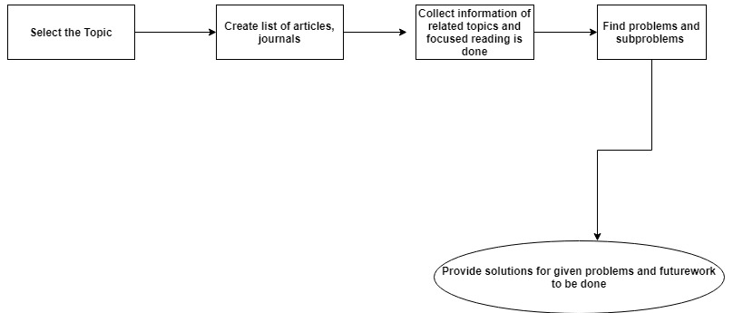

**Figure 4.0.1: Applied methodology for collecting secondary data**

# **7.0 Research Significance**

IOT plays a significant role in every possible thing like smart home, agriculture, medical and health. In agriculture, IOT helps in improving quality and quantity by correct uses of resources. My research paper will highlight all the present technologies used in agriculture and their impact on Indian market. It will also highlight the research problems and their future directions and possible ways to solve the research problems.

This research will be eye opener for future researchers, practitioners, academies to get to know about challenges in IOT in agriculture sector and to come up with more solutions. New policies can come up by researchers to make internet of things grew among farmers.

By reviewing journals, we can come up with various ways to solve problems of farmers. People who are working in agriculture firm in India out of which 60% of farmers belong to below poverty line and earns less than 32 bucks of Indian currency. And using natural elements usually result them in debt and due to which many farmers commit suicide.

This research will include interviews, face to face communications with people that are therein agriculture field and their views on various changes that are being adapted in agriculture. By analysing them, it will be real observations and can create a productive solution for it.

Not only IOT but cloud computing, data mining , data driven techniques can combine for better results in the crop production. Automated irrigation is best method to reduce the man power. To manage the livestock by continuing monitoring, drones monitor the field and temperature variation, sensor sense the soil humidity, nutrients that are essential for crop. Crop diseases are timely taken care for. These all things can be done by IOT which can truly decrease the involvement of man power.

Future researchers will think about this scenario and this research can go beyond and find out ways to flourish the Indian agriculture and India is second largest producer of Agriculture.

# **8.0 Conclusion**

IOT is introduced in agriculture to increase quality and quantity of crop and reduce cost. But seeing the overall scenario in India the cost of introducing IOT is very high which is not very much affordable by small scale farmers. Moreover, they are not really introduced to this side of technology and if they are introduced, they do not really know how to use it. Throughout the research the motive of the research is to give feedback on impact of IOT in agriculture specifically in India and the ways to solve the research problems.

This paper brings about the small problems and focuses on them because these problems are only creating problems in depriving the Indian farmers to use the current technologies. Also, this paper defines the literature review of thirteen Different papers that are studied deeply and analysed completely.

Overall, this paper brings about the proposal on how the research is going to take place in coming weeks. Moreover, it highlights few papers that have been viewed to carry on the study. It highlights the introduction to keywords and their basic knowledge. After it displays how IOT is emerging in agriculture. In the next sections, research papers have been highlighted. The research problems are basic but severe because that problems are making deprived of using new technologies in agriculture. We can create a user interface in a new way of local language which they can listen as well as read so that farmers can easily understand and apply. New ways to farmers to afford the expensive sensors of IOT to use.

# **9.0 Research Planning:**

This research planning is for this semester. All the steps were clearly performed and step by step. The first table shows the planning from week 1 to week 12.

In week 1, the topic was chosen, and related topics were searched. Following by week 1 and week 2 the journals and articles were read. To carry out research proper research plan is made.

|  |  |  |  |  |
| --- | --- | --- | --- | --- |
| **Task Name** | **Duration** | **Start** | **Finish** | **Resource Names** |
| Literature Review (4 articles) | 6 days | 1 august,2019 | 7 august, 2019 | Articles and journals. |
| Literature Review (2 Articles) | 3 days | 8august,2019 | 10 august.2019 | Articles and journals. |
| Writing Proposal | 10 days | 11August,2019 | 22 August,2019 | Ms Word |
| Literature Review (4 articles) | 10 days | 23 august,2019 | 1 september,2019 | Articles and journals. |
| Final report writing | 22 days | 2 september,2019 | 24 september,2019 | Ms Word |
| Presentation | 5 days | 24 september,2019 | 28 september2019 | Microsoft PowerPoint |
| Alteration in report according to feedback | 10 days | 2 october,2019 | 12 october,2019 | Ms Word |

**Table: Research Planning**

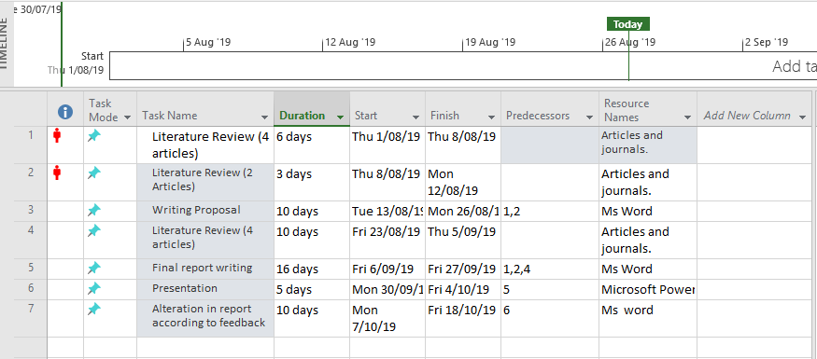These Gantt charts is prepared in MS Project which is very reliable software to perform various task in the project. That’s why for this research Ms Project is used as it is more reliable and easier to use.

**Gantt Chart 1**

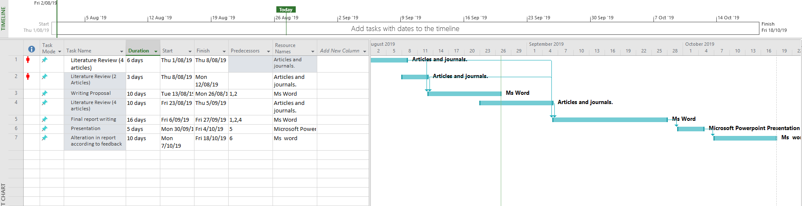**Gantt Chart 2**

# **10.0 References**

Baruah, A. and Mohan, G.M., 2018. THE AGRICULTURAL EXPERTS’VIEW TOWARDS THE USE OF INFORMATION AND COMMUNICATION TECHNOLOGY IN EXTENSION SERVICES IN NER INDIA. Journal of Management (JOM), 5(4).

Ravi mundada, (2016), Iot for Indian Agriculture [ONLINE]. Available at: https://image.slidesharecdn.com/iotforindianagriculture-161229061609/95/iot-for-indian-agriculture-2-638.jpg?cb=1482992307 [Accessed 23 August 2019].

[Blog] cloudera Blog. Available at: https://data-flair.training/blogs/iot-applications-in-agriculture/ [Accessed 24 Aug. 2019].

Vaghjiani, K., 2012. Patterns of IT-enabled innovation adoption in developed and developing countries: A comparative case study of Australian and Indian banking industries (Doctoral dissertation, Ph. D. Thesis.. Available at〈 http://handle. unsw. edu. au/1959. 4/52204).

Malavade, V.N. and Akulwar, P.K., 2016. Role of IoT in agriculture. In National Conference on" Changing Technology and Rural Development" CTRD (pp. 56-57).

Khanna, A. and Kaur, S., 2019. Evolution of Internet of Things (IoT) and its significant impact in the field of Precision Agriculture. Computers and electronics in agriculture, 157, pp.218-231.

Stočes, M., Vaněk, J., Masner, J. and Pavlík, J., 2016. Internet of things (iot) in agriculture-selected aspects. Agris on-line Papers in Economics and Informatics, 8(665-2016-45107), pp.83-88.

Deichmann, U., Goyal, A. and Mishra, D., 2016. Will digital technologies transform agriculture in developing countries?. The World Bank.

Saravanan, R., 2012. ICTs for agricultural extension in India: policy implications for developing countries. In Proc. of 8th Asian Conference for Information Technology in Agriculture, AFITA (pp. 1-11).

Mohanraj, I., Ashokumar, K. and Naren, J., 2016. Field monitoring and automation using IOT in agriculture domain. Procedia Computer Science, 93, pp.931-939.

Verma, N.K. and Usman, A., 2016, October. Internet of Things (IoT): A relief for Indian farmers. In 2016 IEEE Global Humanitarian Technology Conference (GHTC) (pp. 831-835). IEEE.

Mwangi, M. and Kariuki, S., 2015. Factors determining adoption of new agricultural technology by smallholder farmers in developing countries. Journal of Economics and sustainable development, 6(5).

Kansara, K., Zaveri, V., Shah, S., Delwadkar, S. and Jani, K., 2015. Sensor based automated irrigation system with IOT: a technical review. International Journal of Computer Science and Information Technologies, 6(6), pp.5331-5333.

Sangtrash, H.M. and Hiremath, A.S., 2017. Review on IoT for Indian farmers. International Journal of Scientific Research in Computer Science, Engineering and Information Technology, 2(3), pp.236-239.

Satyanarayana, G.V. and Mazaruddin, S.D., 2013, April. Wireless sensor based remote monitoring system for agriculture using ZigBee and GPS. In Proceedings of the Conference on Advances in Communication and Control Systems-2013. Atlantis Press.

Mankar, A.B. and Burange, M.S., 2014. Data Mining-an evolutionary view of agriculture. International Journal of Application or Innovation in Engineering and Management, 3(3), pp.102-105.

Khan, S.F. and Ismail, M.Y., 2018. An Investigation into the Challenges and Opportunities Associated with the Application of Internet of Things (IoT) in the Agricultural Sector-A Review. JCS, 14(2), pp.132-143.

Nesta, (2015), Future farms [Online]. Available at: <https://pbs.twimg.com/media/CRmqOeYUsAAITKh.jpg> [Accessed 24 September 2019].

Dahikar, S.S., Rode, S.V. and Deshmukh, P., 2015. An Artificial Neural Network Approach for Agricultural Crop Yield Prediction Based on Various Parameters. published in International Journal of Advanced Research in Electronics and Communication Engineering (IJARECE), 4(1).

Channe, H., Kothari, S. and Kadam, D., 2015. Multidisciplinary model for smart agriculture using internet-of-things (IoT), sensors, cloud-computing, mobile-computing & big-data analysis. Int. J. Computer Technology & Applications, 6(3), pp.374-382.

Jaiganesh, S., Gunaseelan, K. and Ellappan, V., 2017, March. IOT agriculture to improve food and farming technology. In 2017 Conference on Emerging Devices and Smart Systems (ICEDSS) (pp. 260-266). IEEE.

Rajeswari, S., Suthendran, K. and Rajakumar, K., 2017, June. A smart agricultural model by integrating IoT, mobile and cloud-based big data analytics. In 2017 International Conference on Intelligent Computing and Control (I2C2) (pp. 1-5). IEEE.

Vasisht, D., Kapetanovic, Z., Won, J., Jin, X., Chandra, R., Sinha, S., Kapoor, A., Sudarshan, M. and Stratman, S., 2017. Farmbeats: An iot platform for data-driven agriculture. In 14th {USENIX} Symposium on Networked Systems Design and Implementation ({NSDI} 17) (pp. 515-529).

Karim, F. and Karim, F., 2017. Monitoring system using web of things in precision agriculture. Procedia Computer Science, 110, pp.402-409.

Shekhar Rajput, (2017), *Role Of different sector* [ONLINE]. Available at: https://gs-post-images.grdp.co/2016/8/img1472105943221-95-rs-high-webp.jpg [Accessed 24 September 2019].

softmedialab.com, (2017), Internet of things uses by industry [ONLINE]. Available at: https://softmedialab.com/wp-content/uploads/2018/09/building-IoT-application.jpg [Accessed 24 September 2019]

nesta, (2015), future farms [ONLINE]. Available at: https://pbs.twimg.com/media/CRmqOeYUsAAITKh.jpg [Accessed 24 September 2019].

Ogoxe, (2018), Weather / Meteo Station [ONLINE]. Available at: https://encrypted-tbn0.gstatic.com/images?q=tbn%3AANd9GcTGVsqL5wp36yCk0BDYkEmukf3EdnRcqZ2wRFLbi-gPzdeoavAA [Accessed 24 September 2019].

pycno, (2018), pycno [ONLINE]. Available at: https://encrypted-tbn0.gstatic.com/images?q=tbn%3AANd9GcQmoLyDGnjwc6lkWr70fY24mGXHiUKX74gm8JzTzXFR5UNL9Pao [Accessed 24 September 2019].

My Farm, (2015), interface [ONLINE]. Available at: https://encrypted-tbn0.gstatic.com/images?q=tbn%3AANd9GcSJ5VD4ndnzejiaBmohowl_rHEQ1gI8uCc7uUaX3FKqQjUFtOVH [Accessed 24 September 2019].